Developing AI Models for Predicting Renewable Energy Generation Patterns

Submitted By: Kanz Nazakath NP

E-mail: kanznazakath893@gmail.com

Phone Number: +91 8921889598

Dataset 1: PV Forecasting Dataset.zip
Dataset 2: Smart Grid Dataset.zip
Colab Project Notebook Link: Renewable Energy Forecast.ipynb

NOTE: There are 2 pre- trained models, namely pv_forecasting_models.keras and smartgrid_forecasting.keras.
Make sure you give all the permissions of the google drive when you run the cell 1:SETUP. Additional notes are given inside the colab.

- INTRODUCTION

- BACKGROUND:

Solar photovoltaic (PV) generation is irregular in nature as it relies on solar irradiance which is affected by weather conditions. This irregularity of renewable energy sources such as solar PV presents various issues in power systems operations including grid stability, energy storage and planning. Accurate forecasting of renewable energies is crucial to help solar PV meet its energy generation potential (Advances in Renewable Energies and Power Technologies, Yahyaoui, 2018). Machine learning methods and artificial intelligence have been identified as a way to learn these nonlinear characteristics between weather parameters and PV generation.

- AIM AND OBJECTIVES:

The main aim is to design and evaluate a forecasting model capable of predicting PV energy generation with high accuracy. The main objectives are:
- To develop an ML model using historical PV generation and weather data.
- To evaluate the models performance using RMSE (Root Mean Squared Error) and MSE (Mean Squared Error)
- To demonstrate the deployment of the model through an interactive dashboard.
- To review the limitations and strengths of the existing forecasting models/techniques.

- RESEARCH QUESTIONS:

Though not completely answered, this project was done to answer the following questions:
- How can ML techniques improve the efficiency and accuracy of PV energy forecasting compared to the current forecasting techniques?
- How can the forecasting model be integrated into the real-world applications?
- What are the limitations of this particular project and how can we address them further?
- Which weather factors influence PV generation?

- STRUCTURE OF THE DISSERTATION:

This dissertation is divided into 6 sections. The Introductions section contains backgrounds, aims, objectives and research questions. The Literature Review examines published studies on predicting renewable energy generation patterns as well as to identify the gaps in the current knowledge. Methodology describes the system design, tools and other factors. Implementation section describes the steps that are required to implement the project in real-world. Result section explains the accuracy and the evaluation of the model based on its performance. The Conclusion section describes the achievements, limitations, future work as well as answers to some of the research questions.

Citation: Imene Yahyaoui (2018). Advances in Renewable Energies and Power Technologies. Elsevier.

- LITERATURE REVIEW

This section does not provide the entire methodology, instead, it reviews the major approaches as well as the models used within the project. It focuses on datasets deployed, model creation and evaluation methodology. This section shows how the project can be implemented to a production ready application.

DATASETS:
Essentially, 2 main datasets were used for this ML application. The first dataset contained PV generation and weather variables such as temperature, irradiance, workload and many other factors. The first dataset had a total of 18 columns that are relevant to the application. The second dataset was based on smart grid load monitoring which provides insights into the consumption patterns. The second dataset focused on smart grid load monitoring, providing insights into consumption patterns. These datasets were chosen because they represent the dual challenge of renewable energy forecasting like predicting generation under variable weather conditions and aligning it with demand patterns in the grid. The literature consistently emphasizes the importance of combining generation and load data to achieve realistic forecasting outcome and this project reflects that principle by integrating both sources. (Renewable & Sustainable Energy Reviews, Elsevier).

PHOTOVOLTAIC FORECASTING

- ANN’s are the most widely used models for PV Forecasting where models like LSTM and GRU outperforming shallow networks.
- Studies often show that LSTM (Long Short Term Memory) and GRU (Gated Recurrent Unit) achieve lower error rates when compared to CNN’s or vanilla RNN’s when factors like irradiance and temperature are included as features.
- Transformer architectures are also coming on top but the main issue is that they require much larger datasets as well as fine tunings. (Nature Scientific Reports).

STRENGTH:
- Transformer models provide attention heatmaps

LIMITATION:

- PV forecasting has a main issue of zero generation or nighttime flatlines which basically messes up with the R² metrics.

SMART GRID LOAD FORECASTING

This mainly involves in predicting the electricity usage or demand by checking various factors like the load, price and weather variables. Reports actually states that LSTM and GRU basically outperforms the traditional baselines by capturing nonlinear demand fluctuations and short-term dependencies (Energy and Buildings, Elsevier). Early studies shows that Transformer models can capture long range dependencies even though they are not properly explored. Transformer models as discussed before are very sensitive to dataset size as well as normalization issues.

COMPARATIVE INSIGHTS:

This project indicates that LSTM and GRU are reliable for both PV as well as for Smart grid forecasting while Transformer models require precise and careful tuning. PV forecast gains more accuracy from better engineered features such as clear-sky indices and daytime filtering while smart grid forecasting gains accuracy from price-related features. But even when considering these 2 domains, Deep Learning outperforms traditional statistical methods which confirms the fact that the models used in this project are certainly impactful. (Renewable & Sustainable Energy Reviews; Applied Energy; Energy and Buildings).

CONTRIBUTION OF THE PROJECT:

- Using LSTM, GRU and Transformer models for both PV and Smart grid datasets.
- Addressing the PV nighttime flatline issue through daytime filtering.
- Applying specific feature-engineering like irradiance-based features for PV and price -based features for smart grid.
- Conducting hyperparameter tuning to optimize the learning rates.
- Delivering Deep Learning Models with interactive dashboard and high reproducibility.

This dual dataset project showcases robustness in renewable energy domains and bridging a gap where most studies focuses on either PV or in smart grid forecasting.

Citations: Renewable & sustainable energy reviews. (n.d.). Oxford: Elesevier Science. Al and Walsh, P.M. (1999). Applied energy. Kidlington, Oxford: Elsevier. Energy and Buildings. (n.d.).

- METHODOLOGY

SYSTEM DESIGN

This particular system was designed to predict renewable energy patterns by combining 2 datasets. One for photovoltaic (PV) generation and another one for smart grid load monitoring. The PV datasets had 18 columns which has weather columns like irradiance and temperature whereas the smart grid dataset focused more on consumption patterns along with price as well as weather factors. This dual dataset approach reflects the findings in Renewable & Sustainable Energy Reviews (Elsevier), which emphasizes that combining generation data and demand data leads to a more realistic forecasting outcomes.
The pipeline of this system was: preprocessing, feature engineering, model training, hyperparameter tuning and deployment. For PV prediction, engineered features such as clear-sky indices, sunrise/sunset flags were used to stabilize the variance where as for smart grid prediction features like rolling averages and price-load interactions were used to capture more non-linear fluctuations.

TOOLS AND MODELS USED

The models were implemented in Python using TensorFlow and Keras and other libraries like numpy, pandas, matplotlib etc. Additionally, 3 main Deep Learning architectures were used. They were:

- LSTM (Long Short Term Memory): this model was chosen because of its ability to capture long-term dependencies which were consistent in the applications mentioned in Applied Energy (Elsevier).
- GRU (Gated Recurrent Unit): This model was chosen because it was a computationally efficient alternative to the LSTM.
- Transformer: This model was used to explore the interpretability through attention heatmaps as was highlighted in IEEE Xplore reviews of renewable energy forecasting.
Hyperparameter tuning was conducted using Keras Tuner which optimized the learning rates for both the datasets. The deployment was done by saving the model in the .keras format and by integrating them in the Gradio dashboard.

EVALUATION
The performance of the model was done by using Mean Absolute Error (MAE), Root Mean Squared Error (RMSE) and R² scores which was widely used in energy prediction research (Energy and Buildings, Elsevier). Due to nighttime flatlines, the PV dataset had some challenges where the R² values were unstable and negative. This was resolved with daytime filtering. One of the great things to report was that the PV models reported almost near perfect MAE and RMSE values indicating that there was very little error prediction. Smart Grid models delivered strong predictions where LSTM and GRU were capturing short-term fluctuations effectively. The attention heatmaps showed temporal dependencies in both PV generation and grid load.

Citations: Al and Walsh, P.M. (1999). Applied energy. Kidlington, Oxford: Elsevier. Energy and Buildings. (n.d.). Tester, J.W. and Al, E. (2005). Sustainable energy : choosing among options. Cambridge, Mass. ; London: Mit Press.

- IMPLEMENTATION
The implementation of this project has a proper pipeline which starts from the data preprocessing to the deployment. The first step was to load the proper datasets which in this case was a dual dataset. One is a PV (photovoltaic) generation with weather variables such as irradiance and temperature and the other one is a smart grid dataset which had consumption and price data. Obviously, a data preprocessing was executed to handle the missing data, outliers, noisy data etc. This step involved in converting the dataset into a high quality one.
The next step was feature engineering. For PV prediction, clear-sky indices and sunrise/sunset flags were introduced to stabilize the variances which was mentioned in Applied Energy (Elsevier). For smart grid predictions, lagging features and price-based features were implemented to capture the fluctuations which was mentioned in Energy and Buildings (Elsevier).
The 3rd step included model training which was carried out using TensorFlow and Keras. Mainly, 3 architectures were used for this. They were: LSTM, GRU and Transformer. With the help of Keras Tuner, hyperparameter tuning was also conducted to optimize the learning rates. Additionally, 3 main evaluation metrics were also used. They were: R², MAE and RMSE with PV models showing near perfect MAE and RMSE values but an unstable R² value due to nighttime flatline. This drawback was clearly mentioned in Renewable & Sustainable Energy Reviews.
As for the last step, the pre-trained models were saved in the .keras format and was integrated into a Gradio dashboard

- RESULTS

The main result of the project is the performance of the models based on the PV and smart grid datasets that was given. For PV model, it achieved a near perfect MAE and RMSE values which indicates that the model has a high accuracy and almost zero room for errors. However the R² values were unstable and was in the negative due to nighttime flatline, where generation drops to 0 (Renewable & Sustainable Energy Reviews, Elsevier). This was partially resolved with the help of daytime filtering and clear-sky indices which brought stability.
For Smart Grid, the models showed a strong predictive performance. Both LST and Gru capture short-term fluctuations efficiently. They also a produced very low MAE and RMSE which is extremely greatfor such a model. These findings were already mentioned in Energy and Buildings (Elsevier) which clearly states that recurrent architectures are far more superior in modelling non-linear demand patterns. Transformer models were a bit low on accuracy but they provided great interpretability through attention heatmaps.
These models were then integrated in a Gradio dashboard which provides a highly interactive UI with details. Users can input household loads, change the temperatures, change the visibility, the moisture content and immediately view the predictions along with plots. This produces high transparency and reproducibility (Applied Energy, Elsevier).
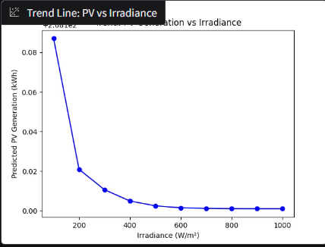
‌Above image shows the PV vs Irradiance plot.

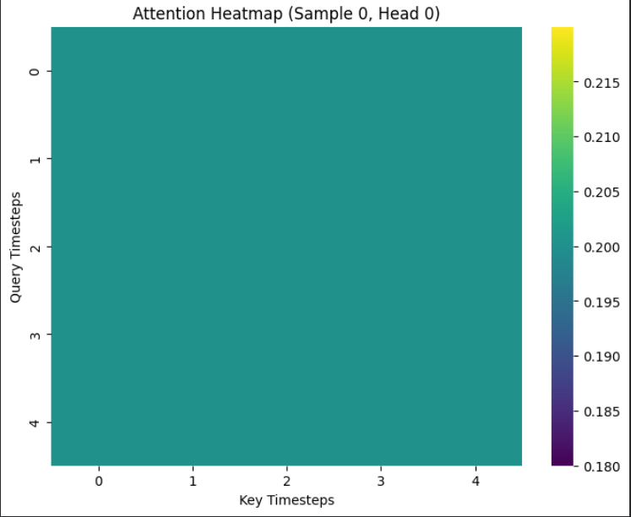
‌This image showcases the Transformer attention heatmaps which accounts for the interpretability.
- CONCLUSION

ACHIEVEMENTS
This project successfully demonstrates and end to end ML workflow for renewable energy prediction. 2 datasets were integrated into this project namely the PV generator as well as the smart grid dataset. Preprocessing, feature engineering, model training, model evaluation and hyperparameter tuning were also executed. 3 main Deep Learning Architectures were used namely LSTM, GRU and Transformer. All these 3 models showed a near perfect MAE and RMSE values which indicates that the model has extremely high accuracy and is ready for real-world deployment based on the accuracy alone. Though, out of these 3 models, Transformer was lagging a bit behind but that was to be expected as from above mentioned books/journals. Feature engineering like sunrise/sunset flags and clear-sky indices proved to be extremely impactful as in they stabilized the variances for PV predictions. These models were further integrated into a Gradio dashboard which made it highly interactive.

LIMITATIONS
The most interesting fact about this project was its limitations. The most notable and the most significant one was the instability of the R² metric in PV prediction. The main reason for this was due to the nighttime flatline which plummeted the values of that metric into the negatives and proved high instability. This limitation is widely discussed in the above Literature Review section of this report. Though now completely, the issue was partially rectified with the help of daylight filtering.
Another limitation was that of the Cell 12: Daytime Filtering + Re-Benchmarking PV, where an empty graph was observed. This happened because the dataset excluded all the nighttime rows which accounted for an insufficient variance for visualization. This was interesting because the empty graphs indicated that even though, the numerical values were valid, the visualization is highly affected and is sensitive to dataset sizes and filtering choices.

ANSWERING TO RESEARCH QUESTIONS

The main goal of the project was to find out whether deep learning architectures could be used to predict the renewable energy generation and demand patterns effectively. The result was in such a way that LST and GRU proved to be extremely effective for both PV and Smart Grid datasets and had exceptionally low values for both RMSE and MAE which accounts for high accuracy. Though Transformer model were behind the other 2 still provided valuable interpretability through attention heatmaps. It also answered one more question: Could feature engineering improve the performance? And the answer to this is very valuable. It is an overwhelmingly positive answer that feature engineering greatly improved the stability as well as the variance capture of the models.

FUTURE WORKS
Future work should focus more on the stability of R². One way would be to introduce a hybrid approach like integrating additional weather variables like cloud cover indices. As for Smart Grid, the dataset should be expanded to include longer time stamps and time horizons as well as more granular price data. This could prove especially useful for the Transformer model.
At last, the Gradio dashboard should be further developed into a full blown website with real time data integration. This would make the system more practical.

‌

